Name: Junbiao Li DUT number:209050796

# Part 1

*Reference*: [Redmon, Joseph, et al. "You only look once: Unified, real-time object detection." *Proceedings of the IEEE conference on computer vision and pattern recognition*. 2016.](https://arxiv.org/abs/1506.02640)

*Word count*:

With Reference: 7035 words

Without Reference: 5981 words

# Part 2

*State number of screenshots:* 2

Other members of: None

*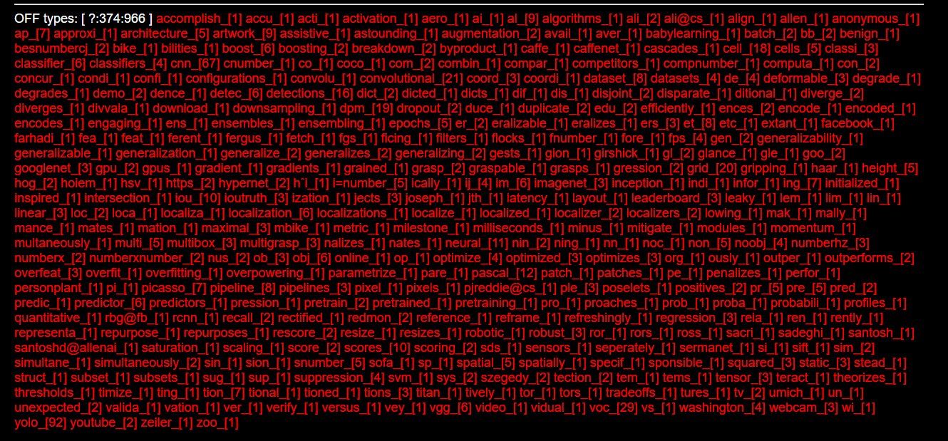

# Part 3

*Complete this table:*

|  |  |  |  |
| --- | --- | --- | --- |
| Word (plus part of speech) | Meaning / Synonyms | Other words in the word family | Information about collocations, word grammar, position in sentence, etc. |
| 1. eliminate (v.) | Meaning: Decrease or make something small enough. (Means in this paper)  Synonyms: Eradicate(v.), Get rid of. | Elimination(n.), Eliminator(n.) | Eliminate poverty, Eliminate illiteracy, Eliminate noise,  Eliminate + n.  It is a predicate verb in a sentence after the subject and before the object. |
| 2. refine (v.) | Meaning: To be improved through tiny adjustments. Synonyms: Improve(v.), Amend(v.) | Refiner(n.) | Refine on,  Refine on + object. |
| 3. generalize (v.) | Meaning: Infer some general principles use some facts or statistic. Synonyms: Infer(v.), Speculate(v.) |  | Generalize about + object.  It as a transitive verb in a sentence is placed before the object. |
| 4. trade-off (n.) | Meaning: Balance two things which is impossible to have both. Weigh the pros and cons between the two. | Balance(n.) | The best trade-off  It is a noun that can be placed at the beginning of the sentence as the subject or in the sentence as the object. |
| 5. regression (n.) | Mathematics Meaning: a measure of the relation between the mean value of one variable. | Regressor(n.) | Regression Analysis, Linear Regression |
| 6. quantitative (adj.) | Meaning: Relating to measuring or measured by the quantity of something rather than its quality. | Quantitatively (adv.) | Quantitative Analysis, Quantitative Research  It is an adjective that can modify the subject at the beginning of the sentence and modify the object in the sentence. It would be placed after the indefinite pronoun. |
| 7. diverge (v.) | Mathematics Meaning: The opposite of converge, be out of line with. | Divergent (adj.) | s.th is diverge from s.th  Diverge function, Diverge sequence |
| 8. methodology (n.) | Meaning: A system of methods to solve a specific problem.  Synonyms: Method(n.) | Methodological(adj.) | Teaching methodology,  Research methodology |

# Part 4

*Sentence 1:*  *Eliminate:* *I used some better algorithms to ELIMINATE the error detection box.*

*Sentence 2:* *Trade-off:* *The speed and accuracy of detection are incompatible, so we chose speed as the TRADE-OFF.*

*Sentence 3:*  *Quantitative: We use QUANTITATIVE tests to evaluate the goodness of the algorithm*

# Part 5

*Insert screenshot images here:*

